5.3 a. Discrete
b. Discrete
c. Continuous
d. Discrete
f. Continuous
g. Continuous
5.12 a. x 1 2 3 4 5
p(x) 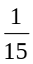 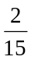 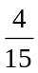
b. p(x) ≥ 0 for each value of x.
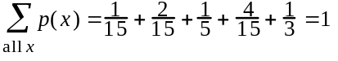
c.
d.

5.24 a.
b. (1) P(x = 5) = .0102
(2) P(x ≥ 3) = 1 – P(x ≤ 2) = 1 – .7443 = .2557
(3) P(x ≤ 2) = .7443
(4) P(x ≥ 1) = 1 – P(x = 0) = 1 – .1176 = .8824
5.48 a. 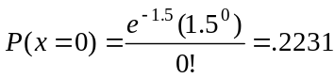
b. P(x < 4) = P(x ≤ 3) = .9344
c. Poisson with μ = 6
P(x ≤ 12) = .9912
d. Poisson with μ = 6
P(x = 0) = .0025

